North Lincolnshire Council
Daily Event Analysis
31st October 2010

Overview
The Amvale Osiris measured a daily mean PM₁₀ concentration of 65µg/m³ on Sunday 31st October 2010 exceeding the allowed 50µg/m³ as a daily mean. Nearby Scunthorpe sites, East Common Lane & Redbourn Club did not exceed the Daily Mean Objective. A check of the data has revealed that the PM₁₀ concentrations were significantly above the 50μg/m³ threshold between 07:00 and 09:30 at the Amvale Osiris. The average PM₁₀ concentration for this time period at Amvale was 156μg/m³.

Met Conditions
Winds varied throughout the day ranging from NW to SE. The wind within the 2 hour & 30 minute period of focus ranged between 357° and 52°. Wind speeds averaged at 1.7 m/s. Light rain was measured in the morning, heavy rain was observed late afternoon.

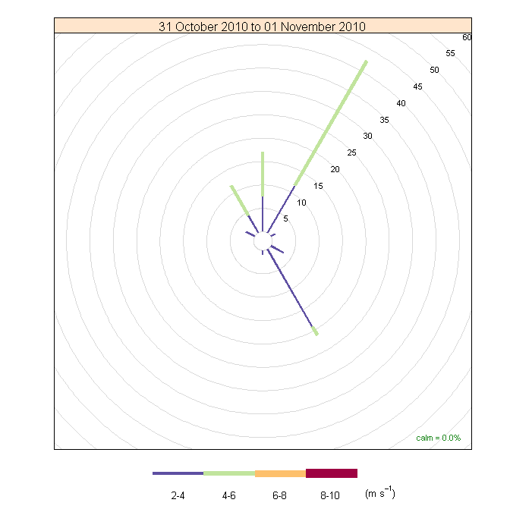

Episode Wind Range

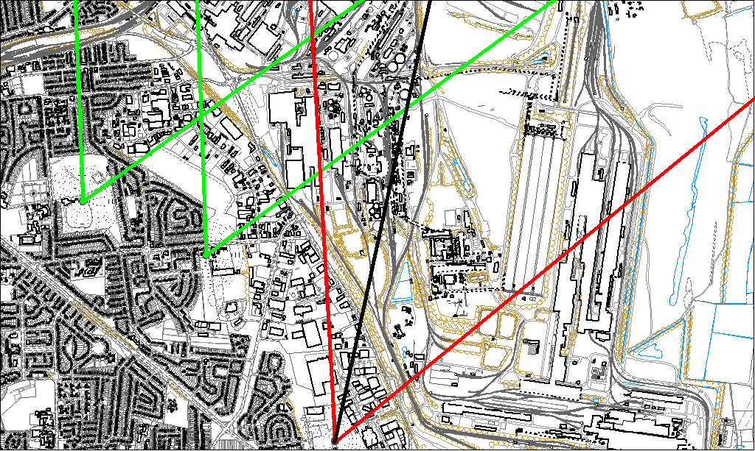

Potential Sources
The above map shows the Amvale Osiris (indicated by the red lines) and the neighbouring Scunthorpe sites of East Common Lane & Redbourn Club (indicated by the green). The black line within the red shows the wind direction of the highest concentration recorded during the 2 hour & 30 minute period of focus.

As the Amvale Osiris measured consistently higher concentrations during this period, it is likely that the Osiris was affected by a different source to the neighbouring TEOMs. Therefore, the areas in which the red and green lines intersect are unlikely to be the location of the problem.

The likely areas include;

- The Sinter Plant
- Civil & Marine
- Ore Beds
- Intermediate Site
- Blast Furnaces

The black line indicates the highest measured concentration of 276 μg/m³ recorded at the Amvale Osiris during this period. It runs through the Blast Furnaces.

